**Project 1: E-learning Company Website Design**

To create the E-learning Company Website Figma tool is used

**Step 1:** E-learning Company Website loading page.



**Step2:** Login page for E-learning Company Website.

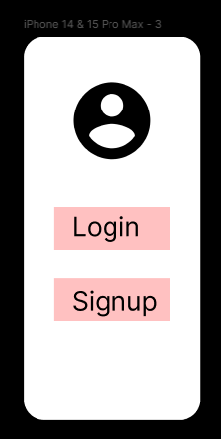

**Step3:** Enter username and password to login to the website.

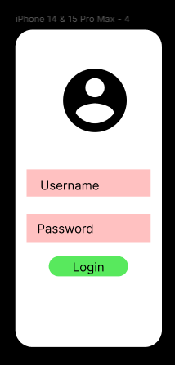

**Step4:** Home page of the E-learning Company Website.

